**Assignment 2**

**Exercise 1**

**a)** Smartwatch App: Google Maps

Concept: This smartwatch application focuses on providing quick and glanceable navigation assistance while on the move.

Storyboard:

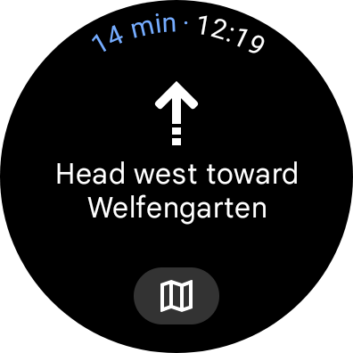

* Description: The watch screen displays a simplified map with the user's current location (blue dot) and the upcoming turn highlighted in a larger font (e.g., "Right turn in 200m").

Image 2: Crossing Ahead

* Description: As the user approaches an intersection, the watch vibrates and displays a more detailed view of the upcoming turn, including street names and lane guidance.

Image 3: Arrived

* Description: Upon reaching the destination, the watch congratulates the user with a simple message ("Arrived!") and displays the option to end navigation.

**b)** Advantages over Smartphone App:

* Quick-view Navigation: The smartwatch app prioritizes quick and discreet information, allowing users to stay focused on their surroundings without needing to take out their phone constantly. This is particularly beneficial for activities like cycling, walking, or exploring new areas.
* Hands-Free: Accessing navigation with a flick of the wrist is much faster and more convenient than using a phone, especially when carrying groceries, holding onto a bike, or using public transport.
* Safety: By minimizing phone use while navigating, this app promotes overall safety by keeping the user's attention on their surroundings and reducing the risk of accidents.
* Battery Efficiency: The simplified display on the smartwatch consumes less battery compared to the larger, constantly lit phone screen.

**Exercise 2**

**c)** We can notice the difference between the patterns when we press on the random button.

**d)**

1. **High Urgency Pattern: "Emergency Alert"**
   * Inspiration: This pattern is inspired by emergency alert systems used in various situations such as natural disasters, severe weather warnings, or urgent notifications.
   * Vibration Pattern: The pattern consists of short, intense bursts of vibration, repeating rapidly to convey a sense of urgency and importance.
   * Use Case: This pattern can be used for critical notifications that require immediate attention, such as emergency alerts, security breaches, or urgent messages from important contacts.
2. **Friendly and Relaxing Pattern: "Gentle Breeze"**
   * Inspiration: This pattern is inspired by the gentle rustling of leaves in a soft breeze, evoking feelings of calmness and relaxation.
   * Vibration Pattern: The pattern starts with a gentle, gradual increase in intensity, mimicking the onset of a breeze. It then transitions into a rhythmic, oscillating vibration, resembling the soothing sensation of a gentle breeze.
   * Use Case: This pattern can be used for notifications intended to provide comfort or relaxation, such as reminders for meditation sessions, bedtime notifications, or calming messages from loved ones.

**Exercise 3**

**a)** The purpose of Material Design is to create a unified system that allows for a consistent and intuitive user experience across different platforms and devices. It aims to provide designers and developers with a set of guidelines, components, and tools to create visually appealing, accessible, and user-friendly interfaces. Material Design emphasizes principles such as simplicity, clarity, and depth to enhance the usability and aesthetics of digital products.

**b)** Material Design was developed by Google in order to create appealing and artistically pleasing user interface (UI) across a large number of platforms and devices. It aims to make the user experience (UX) feel realistic to the user while ensuring a sense of familiarity and easy accessibility.

Material Design has a wide verity of colors and functions that make the experience of the user feel personalized for them and their use. One of the techniques used by Google is Dynamic color which takes a single color from a user's wallpaper or in-app content and creates an accessible color scheme assigned to elements in the UI. Another example would be the huge collection of selection indicators such as check mark icon, checkbox, switch, slider etc.  
In conclusion, the primary goal of Material Design is to create fun and user-friendly experiences that are both visually appealing and functionally efficient. By following these principles, designers are able to create interfaces that are not only aesthetically pleasing but also intuitive to use, enhancing user satisfaction and engagement.